**NCERT solutions for class 10 maths chapter 2 Polynomials Excercise: 2.1**

**Q1 (1)**[The graphs of y = p(x) are given in Fig. 2.10 below, for some polynomials p(x). Find the numbers of zeroes of p(x), in each case.](https://learn.careers360.com/ncert/question-the-graphs-of-y-equals-px-are-given-in-fig-210-below-for-some-polynomials-px-find-the-number-of-zeroes-of-px-in-each-case-graph-1/)

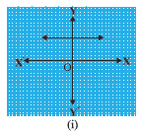

**Answer:**

The number of zeroes of p(x) is zero as the curve does not intersect the x-axis.

**Q1 (2)**[The graphs of y = p(x) are given in Fig. 2.10 below, for some polynomials p(x). Find the number of zeroes of p(x), in each case](https://learn.careers360.com/ncert/question-the-graphs-of-y-equals-px-are-given-in-fig-210-below-for-some-polynomials-px-find-the-number-of-zeroes-of-px-in-each-case-graph-2/)

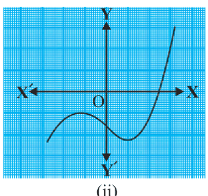

**Answer:**

The number of zeroes of p(x) is one as the graph intersects the x-axis only once.

**Q1 (3)**[The graphs of y = p(x) are given in Fig. 2.10 below, for some polynomials p(x). Find the number of zeroes of p(x), in each case](https://learn.careers360.com/ncert/question-the-graphs-of-y-equals-px-are-given-in-fig-210-below-for-some-polynomials-px-find-the-number-of-zeroes-of-px-in-each-case/)

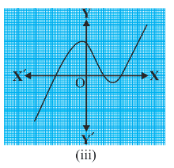

**Answer:**

The number of zeroes of p(x) is three as the graph intersects the x-axis thrice.

**Q1 (4)**[The graphs of y = p(x) are given in Fig. 2.10 below, for some polynomials p(x). Find the number of zeroes of p(x), in each case](https://learn.careers360.com/ncert/question-the-graphs-of-y-equals-px-are-given-in-fig-210-below-for-some-polynomials-px-find-the-number-of-zeroes-of-px-in-each-case-graph-4/)

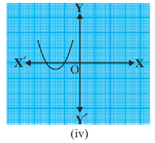

**Answer:**

The number of zeroes of p(x) is two as the graph intersects the x-axis twice.

**Q1 (5)**[The graphs of y = p(x) are given in Fig. 2.10 below, for some polynomials p(x). Find the number of zeroes of p(x), in each case](https://learn.careers360.com/ncert/question-the-graphs-of-y-equals-px-are-given-in-fig-210-below-for-some-polynomials-px-find-the-number-of-zeroes-of-px-in-each-case-graph-5/)

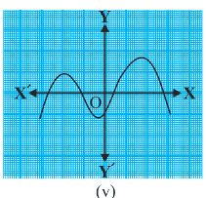

**Answer:**

The number of zeroes of p(x) is four as the graph intersects the x-axis four times.

**Q1 (6)**[The graphs of y = p(x) are given in Fig. 2.10 below, for some polynomials p(x). Find the number of zeroes of p(x), in each case](https://learn.careers360.com/ncert/question-the-graphs-of-y-equals-px-are-given-in-fig-210-below-for-some-polynomials-px-find-the-number-of-zeroes-of-px-in-each-case-graph-6/)

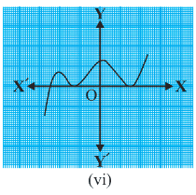

**Answer:**

The number of zeroes of p(x) is three as the graph intersects the x-axis thrice.

**NCERT solutions for class 10 maths chapter 2 Polynomials Excercise: 2.2**

**Q1 (1)**[Find the zeroes of the following quadratic polynomials and verify the relationship between the zeroes and the coefficients.  [x ^2 - 2x -8](http://learn.careers360.com/ncert/question-find-the-zeroes-of-the-following-quadratic-polynomials-and-verify-the-relationship-between-the-zeroes-and-the-coefficients-x-square-minus-2x-minus-8/)](http://learn.careers360.com/ncert/question-find-the-zeroes-of-the-following-quadratic-polynomials-and-verify-the-relationship-between-the-zeroes-and-the-coefficients-x-square-minus-2x-minus-8/)

**Answer:**

x2 - 2x - 8 = 0

x2 - 4x + 2x - 8 = 0

x(x-4) +2(x-4) = 0

(x+2)(x-4) = 0

The zeroes of the given quadratic polynomial are -2 and 4

\\\alpha =-2\\ \beta =4

VERIFICATION

Sum of roots:

\\\alpha+\beta =-2+4=2

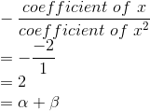

Verified

Product of roots:

\\\alpha \beta =-2\times 4=-8

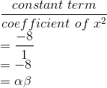

Verified

**Q1 (ii)**[Find the zeroes of the following quadratic polynomials and verify the relationship between the zeroes and the coefficients. [4s^2 - 4s + 1](http://learn.careers360.com/ncert/question-find-the-zeroes-of-the-following-quadratic-polynomials-and-verify-the-relationship-between-the-zeroes-and-the-coefficients-4s-square-minus-4s-plus-1/)](http://learn.careers360.com/ncert/question-find-the-zeroes-of-the-following-quadratic-polynomials-and-verify-the-relationship-between-the-zeroes-and-the-coefficients-4s-square-minus-4s-plus-1/)

**Answer:**

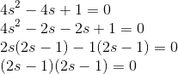

The zeroes of the given quadratic polynomial are 1/2 and 1/2

\\\alpha =\frac{1}{2}\\ \beta =\frac{1}{2}

VERIFICATION

Sum of roots:

\\\alpha +\beta =\frac{1}{2}+\frac{1}{2}=1

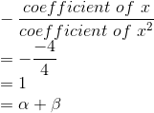

Verified

Product of roots:

\alpha \beta =\frac{1}{2}\times \frac{1}{2}=\frac{1}{4}

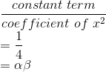

Verified

**Q1 (3)**  [Find the zeroes of the following quadratic polynomials and verify the relationship between the zeroes and the coefficients. [6x ^2 - 3 -7x](http://learn.careers360.com/ncert/question-find-the-zeroes-of-the-following-quadratic-polynomials-and-verify-the-relationship-between-the-zeroes-and-the-coefficients-6x-square-minus-3-minus-7x/)](http://learn.careers360.com/ncert/question-find-the-zeroes-of-the-following-quadratic-polynomials-and-verify-the-relationship-between-the-zeroes-and-the-coefficients-6x-square-minus-3-minus-7x/)

**Answer:**

6x2 - 3 - 7x = 0

6x2 - 7x - 3 = 0

6x2 - 9x + 2x - 3 = 0

3x(2x - 3) + 1(2x - 3) = 0

(3x + 1)(2x - 3) = 0

The zeroes of the given quadratic polynomial are -1/3 and 3/2

\\\alpha =-\frac{1}{3}\\ \beta =\frac{3}{2}

Sum of roots:

\\\alpha+\beta =-\frac{1}{3}+\frac{3}{2}=\frac{7}{6}

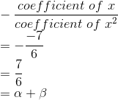

Verified

Product of roots:

\\\alpha \beta =-\frac{1}{3}\times \frac{3}{2}=-\frac{1}{2}

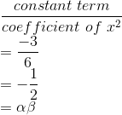

Verified

**Q1 (4)**[Find the zeroes of the following quadratic polynomials and verify the relationship between the zeroes and the coefficients.[4 u^2 + 8u](http://learn.careers360.com/ncert/question-find-the-zeroes-of-the-following-quadratic-polynomials-and-verify-the-relationship-between-the-zeroes-and-the-coefficients-4u-square-plus-8-u/)](http://learn.careers360.com/ncert/question-find-the-zeroes-of-the-following-quadratic-polynomials-and-verify-the-relationship-between-the-zeroes-and-the-coefficients-4u-square-plus-8-u/)

**Answer:**

4u2 + 8u = 0

4u(u + 2) = 0

The zeroes of the given quadratic polynomial are 0 and -2

\\\alpha =0\\ \beta =-2

VERIFICATION

Sum of roots:

\\\alpha +\beta =0+(-2)=-2

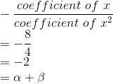

Verified

Product of roots:

\alpha \beta =0\times-2=0

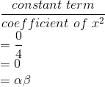

Verified

**Q1 (5)**[Find the zeroes of the following quadratic polynomials and verify the relationship between the zeroes and the coefficients. [t^2 - 15](http://learn.careers360.com/ncert/question-find-the-zeroes-of-the-following-quadratic-polynomials-and-verify-the-relationship-between-the-zeroes-and-the-coefficients-t-square-minus-15/)](http://learn.careers360.com/ncert/question-find-the-zeroes-of-the-following-quadratic-polynomials-and-verify-the-relationship-between-the-zeroes-and-the-coefficients-t-square-minus-15/)

**Answer:**

t2 - 15 = 0

(t-\sqrt{15})(t+\sqrt{15})=0

The zeroes of the given quadratic polynomial are -\sqrt{15} and \sqrt{15}

\\\alpha =-\sqrt{15}\\ \beta =\sqrt{15}

VERIFICATION

Sum of roots:

\\\alpha +\beta =-\sqrt{15}+\sqrt{15}=0

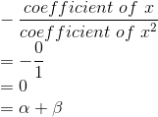

Verified

Product of roots:

\alpha \beta =-\sqrt{15}\times \sqrt{15}=-15

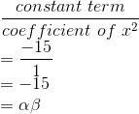

Verified

**Q1 (6)**[Find the zeroes of the following quadratic polynomials and verify the relationship between the zeroes and the coefficients. [3 x^2 - x - 4](http://learn.careers360.com/ncert/question-find-the-zeroes-of-the-following-quadratic-polynomials-and-verify-the-relationship-between-the-zeroes-and-the-coefficients-3x-square-minus-x-minus-4/)](http://learn.careers360.com/ncert/question-find-the-zeroes-of-the-following-quadratic-polynomials-and-verify-the-relationship-between-the-zeroes-and-the-coefficients-3x-square-minus-x-minus-4/)

**Answer:**

3x2 - x - 4 = 0

3x2 + 3x - 4x - 4 = 0

3x(x + 1) - 4(x + 1) = 0

(3x - 4)(x + 1) = 0

The zeroes of the given quadratic polynomial are 4/3 and -1

\\\alpha =\frac{4}{3}\\ \beta =-1

VERIFICATION

Sum of roots:

\\\alpha +\beta =\frac{4}{3}+(-1)=\frac{1}{3}

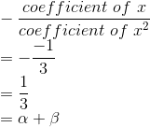

Verified

Product of roots:

\alpha \beta =\frac{4}{3}\times -1=-\frac{4}{3}

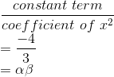

Verified

**Q2 (1)**[Find a quadratic polynomial each with the given numbers as the sum and product of zeroes respectively. 1/4 , -1](https://learn.careers360.com/ncert/question-find-the-zeroes-of-the-following-quadratic-polynomials-and-verify-the-relationship-between-the-zeroes-and-the-coefficients-1-by-4-minus-1/)

**Answer:**

\\\alpha +\beta =\frac{1}{4}\\ \alpha \beta =-1

The required quadratic polynomial is

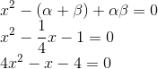

**Q2 (2)**[Find a quadratic polynomial each with the given numbers as the sum and product of zeroes respectively. [\sqrt 2 , 1/3](http://learn.careers360.com/ncert/question-find-the-zeroes-of-the-following-quadratic-polynomials-and-verify-the-relationship-between-the-zeroes-and-the-coefficients-root-1-by-3/)](http://learn.careers360.com/ncert/question-find-the-zeroes-of-the-following-quadratic-polynomials-and-verify-the-relationship-between-the-zeroes-and-the-coefficients-root-1-by-3/)

Answer:

\\\alpha +\beta =\sqrt{2}\\ \alpha \beta =\frac{1}{3}

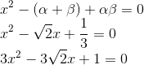

The required quadratic polynomial is 3x^{2}-3\sqrt{2}x+1

**Q2 (3)**[Find a quadratic polynomial each with the given numbers as the sum and product of zeroes respectively. [0,\sqrt{5}](http://learn.careers360.com/ncert/question-find-the-zeroes-of-the-following-quadratic-polynomials-and-verify-the-relationship-between-the-zeroes-and-the-coefficients-0-root-5/)](http://learn.careers360.com/ncert/question-find-the-zeroes-of-the-following-quadratic-polynomials-and-verify-the-relationship-between-the-zeroes-and-the-coefficients-0-root-5/)

**Answer:**

\\\alpha +\beta =0\\ \alpha \beta =\sqrt{5}

\\x^{2}-(\alpha +\beta )+\alpha \beta =0\\ x^{2}-0x+\sqrt{5}=0\\ x^{2}+\sqrt{5}=0

The required quadratic polynomial is x2 + \sqrt{5}.

**Q2 (4)**[Find a quadratic polynomial each with the given numbers as the sum and product of zeroes respectively.  1,1](https://learn.careers360.com/ncert/question-find-the-zeroes-of-the-following-quadratic-polynomials-and-verify-the-relationship-between-the-zeroes-and-the-coefficients-11/)

**Answer:**

\\\alpha +\beta =1\\ \alpha \beta =1

\\x^{2}-(\alpha +\beta )+\alpha \beta =0\\ x^{2}-1x+1=0\\ x^{2}-x+1=0

The required quadratic polynomial is x2 - x + 1

**Q2 (5)**[Find a quadratic polynomial each with the given numbers as the sum and product of zeroes respectively. [-\frac{1}{4} , \frac{1}{4}](http://learn.careers360.com/ncert/question-find-the-zeroes-of-the-following-quadratic-polynomials-and-verify-the-relationship-between-the-zeroes-and-the-coefficients-minus-1-by-4-1-by-4/)](http://learn.careers360.com/ncert/question-find-the-zeroes-of-the-following-quadratic-polynomials-and-verify-the-relationship-between-the-zeroes-and-the-coefficients-minus-1-by-4-1-by-4/)

**Answer:**

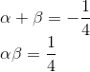

The required quadratic polynomial is 4x2 + x + 1

**Q2 (6)**[Find a quadratic polynomial each with the given numbers as the sum and product of zeroes respectively. 4,1](https://learn.careers360.com/ncert/question-find-the-zeroes-of-the-following-quadratic-polynomials-and-verify-the-relationship-between-the-zeroes-and-the-coefficients-41/)

**Answer:**

\\\alpha +\beta =4\\ \alpha \beta =1

\\x^{2}-(\alpha +\beta )+\alpha \beta =0\\ x^{2}-4x+1=0\\

The required quadratic polynomial is x2 - 4x + 1

**NCERT solutions for class 10 maths chapter 2 Polynomials Excercise: 2.3**

**Q1 (1)**[Divide the polynomial p(x) by the polynomial g(x) and find the quotient and remainder  
in each of the following :  
[(i) p(x) = x^3 - 3x^2 + 5x - 3, g(x) = x^2 - 2](http://learn.careers360.com/ncert/question-divide-the-polynomial-px-by-the-polynomial-gx-and-find-the-quotient-and-remainder-in-each-of-the-following-i-px-x-raised-to-3-minus-3x-square-plus-5x-3/)](http://learn.careers360.com/ncert/question-divide-the-polynomial-px-by-the-polynomial-gx-and-find-the-quotient-and-remainder-in-each-of-the-following-i-px-x-raised-to-3-minus-3x-square-plus-5x-3/)

**Answer:**

The polynomial division is carried out as follows

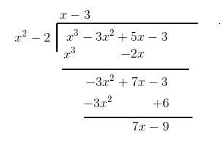

The quotient is x-3 and the remainder is 7x-9

**Q1 (2)**[Divide the polynomial p(x) by the polynomial g(x) and find the quotient and remainder in each of the following : [p(x) = x^4 - 3x^2 + 4x + 5, g(x) = x^2 + 1 - x](http://learn.careers360.com/ncert/question-divide-the-polynomial-px-by-the-polynomial-gx-and-find-the-quotient-and-remainder-in-each-of-the-following-px-x-raised-to-4-minus-3x-raised-to-2-plus-4x-plus-5/)](http://learn.careers360.com/ncert/question-divide-the-polynomial-px-by-the-polynomial-gx-and-find-the-quotient-and-remainder-in-each-of-the-following-px-x-raised-to-4-minus-3x-raised-to-2-plus-4x-plus-5/)

**Answer:**

The division is carried out as follows

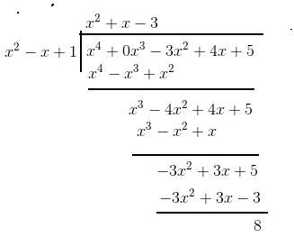

The quotient is x^2+x-3

and the remainder is 8

**Q1 (3)**[Divide the polynomial p(x) by the polynomial g(x) and find the quotient and remainder in each of the following :  
[p(x) = x^4 - 5x + 6, g(x) = 2 - x^2](http://learn.careers360.com/ncert/question-divide-the-polynomial-px-by-the-polynomial-gx-and-find-the-quotient-and-remainder-in-each-of-the-following-px-x-raised-to-4-minus-5x-plus-6/)](http://learn.careers360.com/ncert/question-divide-the-polynomial-px-by-the-polynomial-gx-and-find-the-quotient-and-remainder-in-each-of-the-following-px-x-raised-to-4-minus-5x-plus-6/)

**Answer:**

 The polynomial is divided as follows

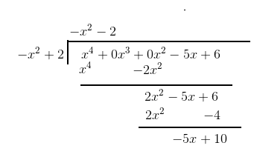

The quotient is -x^2-2 and the remainder is -5x+10

**Q2 (1)**[Check whether the first polynomial is a factor of the second polynomial by dividing the second polynomial by the first polynomial:](https://learn.careers360.com/ncert/question-check-whether-the-first-polynomial-is-a-factor-of-the-second-polynomial-by-dividing-the-second-polynomial-by-the-first-polynomial-t-square-minus-3/)

t^2 - 3, 2t^4 + 3t^3 - 2t^2 - 9t - 12

**Answer:**

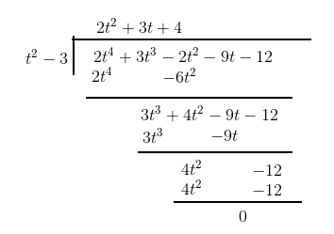

After dividing we got the remainder as zero. So t^2 - 3 is a factor of 2t^4 + 3t^3 - 2t^2 - 9t - 12

**Q2 (2)**[Check whether the first polynomial is a factor of the second polynomial by dividing the second polynomial by the first polynomial:](https://learn.careers360.com/ncert/question-check-whether-the-first-polynomial-is-a-factor-of-the-second-polynomial-by-dividing-the-second-polynomial-by-the-first-polynomial-x-square-plus-3x-plus-1/)

x^2 + 3x + 1, 3x^4 + 5x^3 - 7x^2 + 2x + 2

**Answer:**

To check whether the first polynomial is a factor of the second polynomial we have to get the remainder as zero after the division

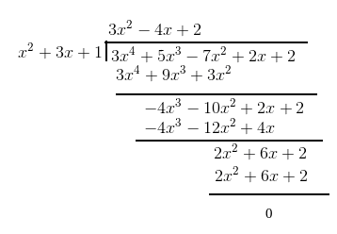

After division, the remainder is zero thusx^2+3x+1 is a factor of 3x^4 + 5x^3 - 7x^2 + 2x + 2

**Q2 (3)**[Check whether the first polynomial is a factor of the second polynomial by dividing the second polynomial by the first polynomial:](https://learn.careers360.com/ncert/question-check-whether-the-first-polynomial-is-a-factor-of-the-second-polynomial-by-dividing-the-second-polynomial-by-the-first-polynomial-x-raised-to-3-minus-3x-plus-1/) x^3 - 3x + 1, x^5 - 4x^3 + x^2 + 3x + 1

**Answer:**

The polynomial division is carried out as follows

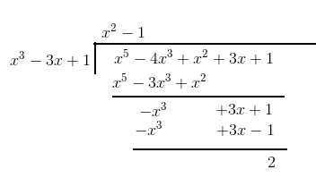

The remainder is not zero, there for the first polynomial is not a factor of the second polynomial

**Q3**[Obtain all other zeroes of [3x^4 + 6x^3 - 2x^2 - 10x - 5](http://learn.careers360.com/ncert/question-obtain-all-other-zeroes-of-3x-raised-to-4-plus-6x-raised-to-3-minus-2x-square-minus-10x-minus-5-if-two-of-its-zeroes-are/), if two of its zeroes are](http://learn.careers360.com/ncert/question-obtain-all-other-zeroes-of-3x-raised-to-4-plus-6x-raised-to-3-minus-2x-square-minus-10x-minus-5-if-two-of-its-zeroes-are/) \sqrt {\frac5{3}} \: \:and \: \: - \sqrt {\frac{5}{3}}

**Answer:**

Two of the zeroes of the given polynomial are \sqrt {\frac5{3}} \: \:and \: \: - \sqrt {\frac{5}{3}}.

Therefore two of the factors of the given polynomial are x-\sqrt{\frac{5}{3}} and x+\sqrt{\frac{5}{3}}

(x+\sqrt{\frac{5}{3}})\times (x-\sqrt{\frac{5}{3}})=x^{2}-\frac{5}{3}

x^{2}-\frac{5}{3}   is a factor of the given polynomial.

To find the other factors we divide the given polynomial with 3\times (x^{2}-\frac{5}{3})=3x^{2}-5

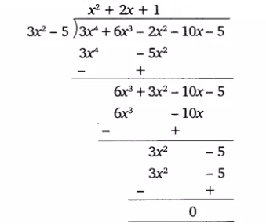

The quotient we have obtained after performing the division is x^{2}+2x+1

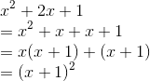

(x+1)2 = 0

x = -1

The other two zeroes of the given polynomial are -1.

**Q4**[On dividing[x^3 - 3x^2 + x + 2](https://learn.careers360.com/ncert/question-on-dividing-x-raised-to-3-minus-3x-raised-to-2-plus-x-plus-2-by-a-polynomial-gx-the-quotient-and-remainder-were-x-minus-2-and-minus-2x-plus-4-respectively-find-gx/) by a polynomial g(x), the quotient and remainder were x – 2 and –2x + 4, respectively. Find g(x).](https://learn.careers360.com/ncert/question-on-dividing-x-raised-to-3-minus-3x-raised-to-2-plus-x-plus-2-by-a-polynomial-gx-the-quotient-and-remainder-were-x-minus-2-and-minus-2x-plus-4-respectively-find-gx/)

**Answer:**

Quotient = x-2

remainder =-2x+4

g(x)=\frac{x^3-3x^2+3x-2}{x-2}

Carrying out the polynomial division as follows

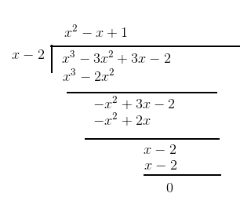

g(x)={x^2-x+1}

**Q5 (1)**[Give examples of polynomials p(x), g(x), q(x) and r(x), which satisfy the division algorithm  
and  
(i) deg p(x) = deg q(x)](https://learn.careers360.com/ncert/question-give-examples-of-polynomials-px-gx-qx-and-rx-which-satisfy-the-division-algorithm-and-deg-px-deg-qx/)

**Answer:**

deg p(x) will be equal to the degree of q(x) if the divisor is a constant. For example

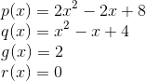

**Q5 (2)**[Give examples of polynomials p(x), g(x), q(x) and r(x), which satisfy the division algorithm and](https://learn.careers360.com/ncert/question-give-examples-of-polynomials-px-gx-qx-and-rx-which-satisfy-the-division-algorithm-and-deg-qx-deg-rx/) [deg q(x) = deg r(x)](http://learn.careers360.com/ncert/question-give-examples-of-polynomials-px-gx-qx-and-rx-which-satisfy-the-division-algorithm-and-deg-qx-deg-rx/)

**Answer:**

Example for a polynomial  with deg q(x) = deg r(x) is given below

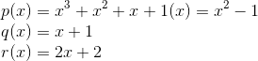

**Q 5 (3)**[Give examples of polynomials p(x), g(x), q(x) and r(x), which satisfy the division algorithm and  deg r(x) = 0](https://learn.careers360.com/ncert/question-give-examples-of-polynomials-px-gx-qx-and-rx-which-satisfy-the-division-algorithm-and-deg-rx-0/)

**Answer:**

example for the polynomial which satisfies the division algorithm with r(x)=0 is given below

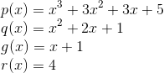

**NCERT solutions for class 10 maths chapter 2 Polynomials Excercise: 2.4**

**Q1 (1)**[Verify that the numbers given alongside the cubic polynomials below are their zeroes.  
Also verify the relationship between the zeroes and the coefficients in each case:](https://learn.careers360.com/ncert/question-verify-that-the-numbers-given-alongside-of-the-cubic-polynomials-below-are-their-zeroes-also-verify-the-relationship-between-the-zeroes-and-the-coefficients-in-each-case-2x-raised-to-3-plus-x-square-minus-5x-plus-2/)  
2x^3 + x^2 - 5x +2 ; \frac{1}{2} , 1 , -2

**Answer:**

p(x) = 2x3 + x2 -5x + 2

p(1) = 2 x 13 + 12 - 5 x 1 + 2

p(1) =2 + 1 - 5 + 2

p(1) = 0

p(-2) = 2 x (-2)3 + (-2)2 - 5 x (-2) +2

p(-2) = -16 + 4 + 10 + 2

p(-2) = 0

Therefore the numbers given alongside the polynomial are its zeroes

Verification of relationship between the zeroes and the coefficients

Comparing the given polynomial with ax3 + bx2 + cx + d, we have

a = 2, b = 1, c = -5, d = 2

The roots are \alpha ,\beta \ and\ \gamma

\\\alpha=\frac{1}{2}\\ \beta =1\\ \gamma =-2

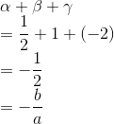

Verified

Verified

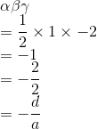

Verified

**Q1 (2)**[Verify that the numbers given alongside the cubic polynomials below are their zeroes. Also, verify the relationship between the zeroes and the coefficients in each case:](https://learn.careers360.com/ncert/question-verify-that-the-numbers-given-alongside-of-the-cubic-polynomials-below-are-their-zeroes-also-verify-the-relationship-between-the-zeroes-and-the-coefficients-in-each-case-x-raised-to-3-minus-4x-raised-to-2-plus-5x-minus-2/)

x ^ 3- 4x ^ 2 + 5x - 2 ; 2,1,1

**Answer:**

p(x) = x3 - 4x2 + 5x - 2

p(2) = 23 - 4 x 22 + 5 x 2 - 2

p(2) = 8 - 16 + 10 - 2

p(-2) = 0

p(1) = 13 - 4 x 12 + 5 x 1 - 2

p(1) = 1 - 4 + 5 - 2

p(1) = 0

Therefore the numbers given alongside the polynomial are its zeroes

Verification of relationship between the zeroes and the coefficients

Comparing the given polynomial with ax3 + bx2 + cx + d, we have

a = 1, b = -4, c = 5, d = -2

The roots are \alpha ,\beta \ and\ \gamma

\\\alpha=2\\ \beta =1\\ \gamma =1

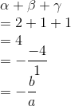

Verified

Verified

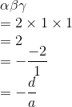

Verified

**Q2**[Find a cubic polynomial with the sum, sum of the product of its zeroes taken two at a time, and the product of its zeroes as 2, –7, –14 respectively.](https://learn.careers360.com/ncert/question-find-a-cubic-polynomial-with-the-sum-sum-of-the-product-of-its-zeroes-taken-two-at-a-time-and-the-product-of-its-zeroes-as-2-minus-7-minus-14-respectively/)

**Answer:**

Let the roots of the polynomial be \alpha ,\beta \ and\ \gamma

\\\alpha +\beta +\gamma =2\\ \alpha \beta +\beta \gamma +\gamma \alpha =-7\\ \alpha \beta \gamma =-14

Hence the required cubic polynomial is x3 - 2x2 - 7x + 14 = 0

**Q3**[If the zeroes of the polynomial [x^3 - 3 x^2+ x +1](http://learn.careers360.com/ncert/question-if-the-zeroes-of-the-polynomial-x-cube-minus-3x-square-plus-x-plus-1-are-a-minus-b-a-a-plus-b-find-a-and-b/)  are a – b, a, a + b, find a and b.](http://learn.careers360.com/ncert/question-if-the-zeroes-of-the-polynomial-x-cube-minus-3x-square-plus-x-plus-1-are-a-minus-b-a-a-plus-b-find-a-and-b/)

**Answer:**

x^3 - 3 x^2+ x +1

The roots of the above polynomial are a, a - b and a + b

Sum of the roots of the given plynomial = 3

a + (a - b) + (a + b) = 3

3a = 3

a = 1

The roots are therefore 1, 1 - b and 1 + b

Product of the roots of the given polynomial = -1

1 x (1 - b) x (1 + b) = - 1

1 - b2 = -1

b2- 2 = 0

b=\pm \sqrt{2}

Therefore a = 1 and b=\pm \sqrt{2}.

**Q4**[If two zeroes of the polynomial [x^4 - 6x ^3 - 26 x^2 + 138 x - 35x^4 - 6x ^3 - 26 x^2 + 138 x - 35](http://learn.careers360.com/ncert/question-if-two-zeroes-of-the-polynomial-x-raised-to-4-minus-6x-raised-to-3-minus-26x-raised-to-2-plus-138x-minus-35-are-2-plus-minus-root-3-find-other-zeroes/)are[2 \pm \sqrt 3](http://learn.careers360.com/ncert/question-if-two-zeroes-of-the-polynomial-x-raised-to-4-minus-6x-raised-to-3-minus-26x-raised-to-2-plus-138x-minus-35-are-2-plus-minus-root-3-find-other-zeroes/) , find other zeroes](http://learn.careers360.com/ncert/question-if-two-zeroes-of-the-polynomial-x-raised-to-4-minus-6x-raised-to-3-minus-26x-raised-to-2-plus-138x-minus-35-are-2-plus-minus-root-3-find-other-zeroes/).

**Answer:**

Given the two zeroes are

2+\sqrt{3}\ and\ 2-\sqrt{3}

therefore the factors are

[x-(2+\sqrt{3})]\ and[x-(\ 2-\sqrt{3})]

We have to find the remaining two factors. To find the remaining two factors we have to divide the polynomial with the product of the above factors

Now carrying out the polynomial division

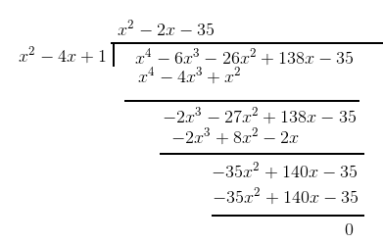

Now we getx^2-2x -35 \ is \ also \ a\ factor

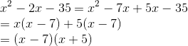

So the zeroes are 2+\sqrt{3}\ ,\ 2-\sqrt{3},7\ and\ -5

**Q5**[If the polynomial [x ^4 - 6x ^3 + 16 x^2 - 35 x + 10](http://learn.careers360.com/ncert/question-if-the-polynomial-x-raised-to-4-minus-6x-raised-to-3-plus-16x-raised-to-2-minus-25x-plus-10-is-divided-by-another-polynomial-x-raised-to-2-minus-2x-plus-k-the-remainder-comes-out-to-be-x-plus-a-find-k-and-a/)  is divided by another polynomial [x^2 - 2x + k](http://learn.careers360.com/ncert/question-if-the-polynomial-x-raised-to-4-minus-6x-raised-to-3-plus-16x-raised-to-2-minus-25x-plus-10-is-divided-by-another-polynomial-x-raised-to-2-minus-2x-plus-k-the-remainder-comes-out-to-be-x-plus-a-find-k-and-a/), the remainder comes out to be x + a, find k and a.](http://learn.careers360.com/ncert/question-if-the-polynomial-x-raised-to-4-minus-6x-raised-to-3-plus-16x-raised-to-2-minus-25x-plus-10-is-divided-by-another-polynomial-x-raised-to-2-minus-2x-plus-k-the-remainder-comes-out-to-be-x-plus-a-find-k-and-a/)

**Answer:**

The polynomial division is carried out as follows

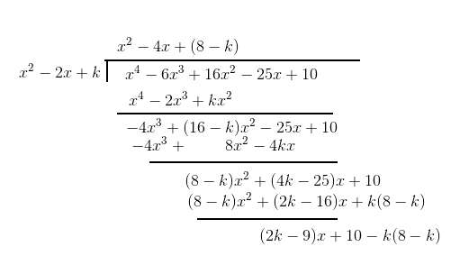

 Given the remainder =x+a

The obtained remainder after division is (2k-9)x+10-k(8-k)

now equating the coefficient of x

2k-9=1

which gives the value of k=5

now equating the constants

a=10-k(8-k)=10-5(8-5)=-5

Therefore k=5 and a=-5